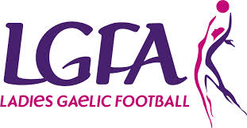
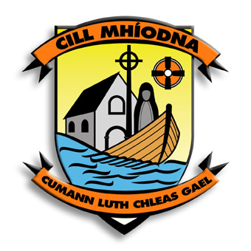
Membership Application Form 2021

I / We hereby apply for Membership of Kilmeena G.A.A. Club / Membership of Kilmeena Ladies Gaelic Football Club

Annual Membership Fees
The following L.G.F.A levies apply to options 1, 2 & 3 only
Under 10 Girl €30 Extra Under 12 Girl to Adult Ladies €50 Extra
1. Cairde Kilmeena €170 (LGFA levy applies to this membership, if girls are being registered)
(includes club membership for family & Annual Lotto & County Board Draw)
2. Family Membership & Annual Lotto €150 (LGFA levy applies to this membership, if girls are registered)
N.B. (Over-18’s included in family membership, must be in full time education)
3. Family Membership €130 (LGFA levy applies to this membership, if girls are registered)
4. Single Membership - Playing Member €100 (Men’s and Ladies)
5. Nursery programme (4 to 8 year old’s) €50
6. Annual Lotto €80 - Any four numbers between 1 and 32 ______ ______ ______ _______
7. Social Member €50
Name | Address | Date of Birth | Gender Male/Female
New Members Only – If applying for membership for the first time, you must be proposed and have the signatures of two full members of the Kilmeena GAA club

Signature of Full Member proposing New Member ________________________________________________

Print Name ______________________________________ Date __________________________

Signature of Full Member proposing New Member ________________________________________________

Print Name ______________________________________ Date __________________________

I hereby apply to Kilmeena G.A.A. Club for membership of the Club and the Association Cumann Luthchleas Gael/Ladies Gaelic Football association (delete as appropriate).
I subscribe to and undertake to further the aims and objectives of the Gaelic Athletic Association/the LGFA (delete as appropriate) and to abide by its Rules including its Code of Behaviour (Underage) which is available at https://www.gaa.ie/the-gaa/child-welfare-and-protection/

Signed ________________________________________________ Date ___________________________

Print Name _____________________________________________

Parent or Guardian’s Contact Phone Number(s) ____________________________________________________

Parent or Guardian’s Contact Email ____________________________________________________________

Please outline any medical information (i.e. allergies, conditions, medications) which may impact on your Childs health, welfare, behaviour, while participating in the Clubs activities. ________________________________________________________________________________________________________________________________________________________________________________________________________________________________________________________________________________________________________________________________

- I consent to the processing of the personal medical data as outlined above for the purpose of administering medical assistance to my child if required.
- In the event of illness/injury, I give permission for medical treatment to be administered by a nominated first aider, or by suitably qualified medical practitioners.
- If I cannot be contacted and my child requires emergency hospital treatment, I authorise a qualified medical practitioner to provide emergency treatment or medication.

Parent/Guardian, on behalf of the above named:

- I/We consent to the above application and to undertakings given by the Applicant.
- I/We understand the personal data on this form will be used by the Club and the Association for the contractual purpose of registering and maintaining the Applicants Membership.
- I/We understand that the Personal Data will be retained by the Club and the Association for such period as the Applicants Membership subsists and for a reasonable period thereafter.
- I/We understand that I/We can resign the Applicants Membership by writing to the Club or the Association and their Personal Data will then be erased except where the Club or the Association has a clear justification to retain such Personal Data (e.g. for Child Safeguarding Purposes).
- I/We understand that the Applicants Personal Data will also be used for administrative purposes to maintain their Membership including Club and team administration, registrations, team sheets, referee reports, disciplinary matters, injury reports, sanctions, permits, and for statistical purposes.
- I/We understand that if I/We do not provide the Applicants Personal Data their Membership cannot be registered with the Club and the Association.

I have read the important Data Protection information and have given my consent, by ticking the boxes and signing below, for my information to be used as follows (Please tick as appropriate).

- To provide me on my own behalf, and on behalf of my child with updates regarding Club activities such as games, training meetings and Club events.
- I am aware that my child’s photograph or Video image may be taken whilst attending or participating in games or activities connected with the Club and I consent to it being used in the promotion of Gaelic Games in print, online/digital and social media mediums of communication.
- My Contact preferences are as follows: GAA App Message☐ SMS Text Message ☐ Email ☐

Signed ______________________________________ Date ________________________
Print Name____________________________________________

Fee Paid: _____________ Payment Type: Cash Cheque CTMÉ S.O.

For Club Registrar’s Use Only:
Membership approved by Club Executive on ________________ (date)
Sínithe: ______________________________ (Rúnaí / Cláraitheoir)
Registered in Membership Database on ________________ (date)
Membership Identification Number(s):

